**New Energy Vehicle Industry**

**Analysis Report**

**1. New Energy Vehicle Industry**

**1.1 Introduction**

**1.2 Industry Structure**

**2. Fama-French Model Empirical Analysis**

**2.1 Sample Data Selection and Processing**

**2.2 Model Setting**

**2.3 Regression Results**

**3. Machine Learning Network Model**

**3.1 Artificial Neural Network Model**

**3.2 Statistical Parameter Model**

**3.3 Empirical Analysis**

**1. New Energy Vehicle Industry**

**1.1 Introduction**

New energy vehicle refers to the vehicle with advanced technical principles, new technology and new structure, which uses unconventional vehicle fuel as the power source (or uses conventional vehicle fuel and new on-board power unit) and integrates the advanced technologies in vehicle power control and drive. Electric vehicle is a typical representative of new energy vehicles. Electric vehicle refers to a vehicle that is powered by an electric motor and powered by on-board energy storage components. Electric vehicles are mainly divided into pure electric vehicles, hybrid electric vehicles and fuel cell vehicles. Battery Electric Vehicle (BEV for short) refers to a vehicle driven by motor and powered by on-board power supply. As the impact on the environment is relatively small compared with traditional cars, its prospects are widely optimistic. At present, its population is in a rapid growth stage. It still has the problem of exhaust pollution. Pure electric vehicles do not have engines, and the national policy supports them more. Although the fuel cell vehicle (FCV) can achieve environmental protection in theory, there are still technical obstacles in the process of producing pure hydrogen and safely storing hydrogen. At this stage, the production of hydrogen energy takes twice the effort and half the effort. The cost of infrastructure measures such as base stations is much higher than that of pure electric vehicle refueling stations, so hydrogen fuel cell vehicles are severely limited. We can think that in the future, pure electric vehicles will occupy the main new energy vehicle market.

**1.2 Industrial structure of new energy vehicles**

Upstream: raw materials

The upstream mainly provides raw materials and parts for the mid stream vehicle manufacturing, and the raw materials for body manufacturing include steel, glass, carbon fiber, etc. The battery, the most important core component of new energy vehicles, is made of lithium, copper, cobalt, nickel, aluminum, graphite, rare earth and other mineral resources. Therefore, the distribution and price of mineral resources will greatly affect the production costs of new energy vehicle enterprises. The power battery consists of four parts, namely, positive material, negative material, electrolyte and diaphragm. Among them, the cost of cathode materials is the highest, so the classification of batteries is mainly based on different cathode materials. The mainstream cathode materials in the market are lithium iron phosphate, lithium nickel oxide, lithium manganate, lithium cobalt oxide, nickel cobalt aluminum ternary, and nickel cobalt manganese ternary. Lithium phosphate battery and ternary lithium battery are the most common.

The upstream raw material resource attribute of new energy vehicles is heavy. With the change of supply and demand structure, the supply of products has

Strong periodicity. At present, many raw materials in China rely on imports, and their prices are highly related to the overall expectations of the future industry. The prosperity of the global new energy industry continues to rise, so the rising trend of mineral resource supply continues to strengthen. Lithium metal has entered the third round of price rise; Due to the impact of the epidemic situation in the new library, the production and supply of cobalt resources in Congo are tight, and the superposition of China's rising demand directly increases the price of cobalt metal. China's motor energy efficiency improvement plan also further promoted the price increase of rare earth permanent magnet. In the future, we can continue to pay attention to relevant enterprises in cobalt, lithium, rare earth permanent magnet, etc.

Midstream: parts and system integration

Components are divided into general and core components. Conventional parts refer to traditional body, chassis, on-board electronic equipment, etc. Core parts refer to battery, motor and electric control, collectively referred to as "three electricity system". The general trend of new energy vehicles is towards electrification and intelligence. If you want to speed up the trend of electrification and intelligence, the focus is on the upgrading and transformation of the "three electricity system". The "three electricity system" accounts for more than 50% of the total cost of new energy vehicles, which is of great importance. For the whole new energy vehicle, the battery, motor and electric control parts are equivalent to the starting of traditional fuel vehicles.

The development of aero electric and tri electric technologies is related to the key indicators of new energy vehicles, such as endurance mileage and power system. Battery is the most important part of the three electric vehicles, accounting for 40% of the total cost of electric vehicles. Battery is also a leading field in China at this stage. The suppliers of batteries and battery materials are the core assets of lithium battery of A-share. Batteries are mainly divided into power batteries, such as lithium batteries and hydrogen fuel cells. The localization of lithium battery is relatively high and the technology is relatively mature. Hydrogen fuel cell is the future development trend, but it is still in the cultivation period. The future development direction of lithium battery is lithium iron phosphate battery and ternary lithium battery. The energy density of the ternary lithium battery is about 20% higher than that of the ordinary lithium iron phosphate, which has more advantages in the endurance. At present, the cost of lithium iron phosphate is lower than that of ternary battery (the price of cobalt metal rises, and the relative price of ternary lithium rises all the way). However, if the price of raw materials of ternary lithium battery, such as cobalt, nickel, manganese, falls in the later period, the advantages of ternary lithium battery will be reflected. Therefore, ternary cobalt battery has more imagination space. However, due to the high ignition point and low price of lithium iron phosphate, from the perspective of safety and cost, lithium iron phosphate is still an important means for automobile enterprises to accelerate the production and ensure growth.

Downstream: vehicle manufacturing and service

Downstream mainly refers to vehicle manufacturing and its supporting services. Main types of market participants of new energy vehicles. It falls into the following three categories. The first category: traditional car companies, including Tesla, the current industry leader, and some traditional and old car companies that it targets, such as BYD, SAIC, Great Wall, Geely, etc. The second category: new forces of car making, mainly represented by Weilai, Ideals and Xiaopeng. The advantages of this type of car body lie in its strong innovation ability and relatively new marketing mode. However, the capital is insufficient and the technology is not very mature, relying on suppliers. Therefore, the delivery capacity is weak and the production capacity is not sufficient. The third category: Internet companies that build cars across borders, including Huawei, Xiaomi, Alibaba, Baidu and other ecological giants.

Vehicle manufacturing has high requirements on the basis, but this aspect has always been a weak link in the development of China's automobile enterprises. At present, among domestic car enterprises, BYD and SAIC Motor Group have a large investment in infrastructure and a large market share, but BYD's industrial chain is relatively more complete. Although traditional automobile enterprises have abundant capital and rich production experience, they are still weak in innovation and software technology. With the development of electrification and intelligence of new energy vehicles, car building must rely on the Internet and intelligent technology. It is not feasible for traditional car enterprises to continue to follow the old path. Huawei and Xiaomi, which build cars across borders, have some Internet and intelligent technologies, as well as certain industrial chain integration capabilities. Therefore, the penetration of new energy vehicles is a severe challenge for the old car enterprises. In the later period, the traditional car companies either accelerated the pace of innovation and R&D, or cooperated with cross-border car manufacturing companies (such as Huawei) for win-win results, or they were likely to be eliminated from the market.

The most important part of supporting services is charging. With the accelerated penetration of new energy vehicles, charging must be solved. The energy supply of new energy vehicles can be completed through charging and changing. Downstream charging equipment is mainly divided into charging pile, charging station and power exchange station. Among them, the total gap of charging piles is relatively large, especially for public charging piles. Statistics show that by 2030, the number of new energy vehicles in China is expected to exceed 60 million. According to the construction goal of 1:1 ratio of vehicle piles, the construction scale of charging piles in the future will be more than 60 million. However, by 2020, the number of charging piles in China is only 1.67 million, and the future market space is huge. The upstream of charging equipment is mainly the manufacturer, which is responsible for the manufacturing of charging equipment and power distribution equipment; The midstream operators are mainly responsible for the construction and operation of charging piles and charging stations; Downstream mainly provides solutions for service, payment and operation management. In the entire industrial chain, equipment manufacturers, charging operators and overall solution providers all play a very important role, and the three often overlap. It is predicted that by 2025, the scale of equipment production market will reach more than 100 billion yuan. The scale of charging operation market will reach 162 billion yuan, and the space of the whole charging market will be relatively large in the future. With the improvement of the new energy vehicle industry chain, it will also continue to spawn a back-end service market in the later period, such as repair and maintenance, battery repair, second-hand car trading, battery recycling and other after-sales service businesses. These will continue to improve as the penetration rate of new energy vehicles increases.

**2. New Energy Vehicle Industry**

**2.1 Sample Data Selection and Processing**

In a real sense, the global electric vehicles should enter the public's vision from 2015, when the annual sales of electric vehicles were only 540000, accounting for less than 1% of the overall sales of automobiles. Therefore, the database used in this paper is the CSMAR database, and the selected samples are the upstream enterprises of the new energy automobile industry chain from 2015 to early 2022: Salt Lake, Northern Rare Earth, Rongjie, Huayou Cobalt; Midstream enterprises: Founder Motor, Changying Xinzhi, Ningde Times, Guoxuan High Tech; Downstream enterprises: BYD, Great Wall Motors, Chang'an Automobile, SAIC Group. The selected stocks are mainly concentrated in industrial chain leaders or companies with high technology level, which are representative. An overview of the entire industrial chain can be obtained by comparing the situation of these companies. At the same time, use the industrial chain of the selected company to build an equal weight portfolio of upstream, midstream and downstream of the industrial chain, so as to better investigate the performance of different ends of the entire industrial chain under the Fama French three factor model.

**2.2 Model Setting**

Fama-French Model:

In the upper formula, represents the yield of stock portfolio i at time t,

expressed in terms of individual stock return considering dividend reinvestment.

represents the risk-free interest rate, which is calculated directly from the CSMAR database. respectively represent the market portfolio yield at time t, the risk premium of the company portfolio with low circulating market value and the company portfolio with high circulating market value, and the risk premium of the value company portfolio and the growth company portfolio. To simplify the calculation, the CSMAR database is directly used for the calculation results of these three companies.

**2.3 Regression Results**

Regression of upstream, midstream and downstream companies in the industrial chain is carried out, and the results are as follows:

2.3.1 Regression results of upstream companies in the industrial chain 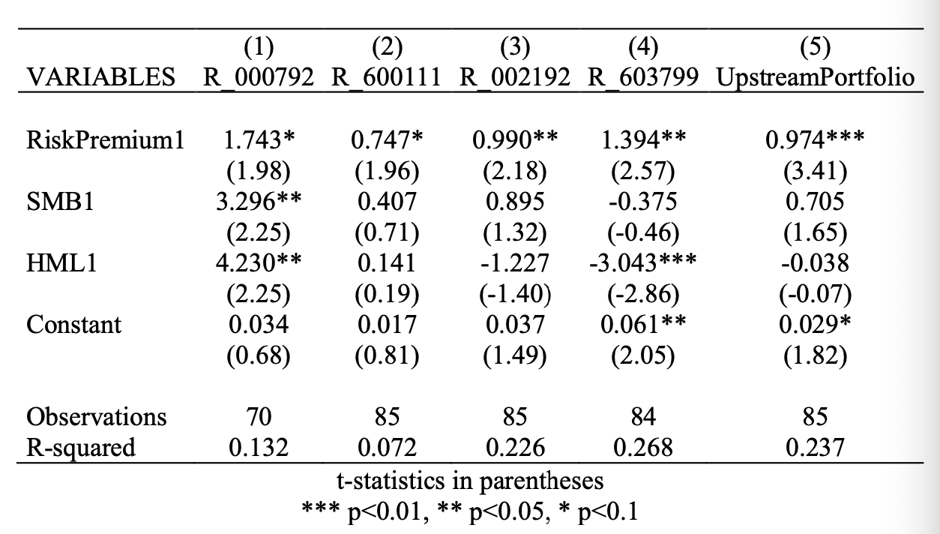

The companies in the above regression results are respectively Salt Lake (000792), North Rare Earth (600111), Rongjie (002192) and Huayou Cobalt (603799), which are representative companies of upstream raw materials lithium, rare earth and cobalt. It can be seen that the market premium factor among the three factors is the most significant among the four companies and the upstream companies' investment portfolios, which indicates that the market risk premium factor is still the most significant factor in explaining the return of portfolio. The constant term of regression is not significant in Salt Lake (000,792), Northern Rare Earth (600,111) and Rongjie (002,192), which shows that the three factors of Fama French model can well explain the systematic risks of these three companies. The constant term of Huayou Cobalt Industry (603799) and the upstream company's investment portfolio is relatively significant, which indicates that some of the excess returns of Huayou Cobalt Industry (603799) are not captured by the three factors, thus causing that some of the excess returns of the entire investment portfolio are not captured by the three factors. This part of excess income may come from the continuous rise in the prices of cobalt, lithium and rare earth driven by low inventory and strong demand, that is, the upstream of the industrial chain is relatively prosperous. This suggests that we may need to further explore the factor model to better explain the excess return of upstream enterprises of new energy vehicles. At the same time, the four companies and the investment portfolio are relatively small, and the model explanation is weak, which may be caused by the gradual boom of upstream raw material companies in recent years.

2.3.2 Regression results of midstream companies in the industrial chain

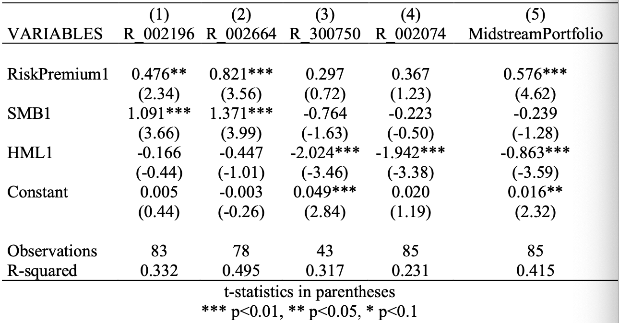

The companies in the above regression results are Founder Motor (002196), Changying Xinzhi (002664), Ningde Times (300750), and Guoxuan Hi Tech (002074). The first two companies are motor companies in the middle of the industrial chain, and the last two are battery companies in the middle of the industrial chain. Founder Motor and Ningde Times are high-tech emerging enterprises, while Changying Xinzhi and Guoxuan Hi Tech are both old companies that deeply cultivate the industrial chain. From the regression results, we can see that the model is more powerful in explaining the excess return rate of motor companies, which may be related to the long-term stable development of motor companies. In contrast, the boom of battery companies in recent years makes it difficult for the model to explain. At the same time, the larger size of battery companies also shows that battery enterprises are more dynamic than motor enterprises in the middle of the industrial chain.

2.3.3 Regression results of downstream companies in the industrial chain

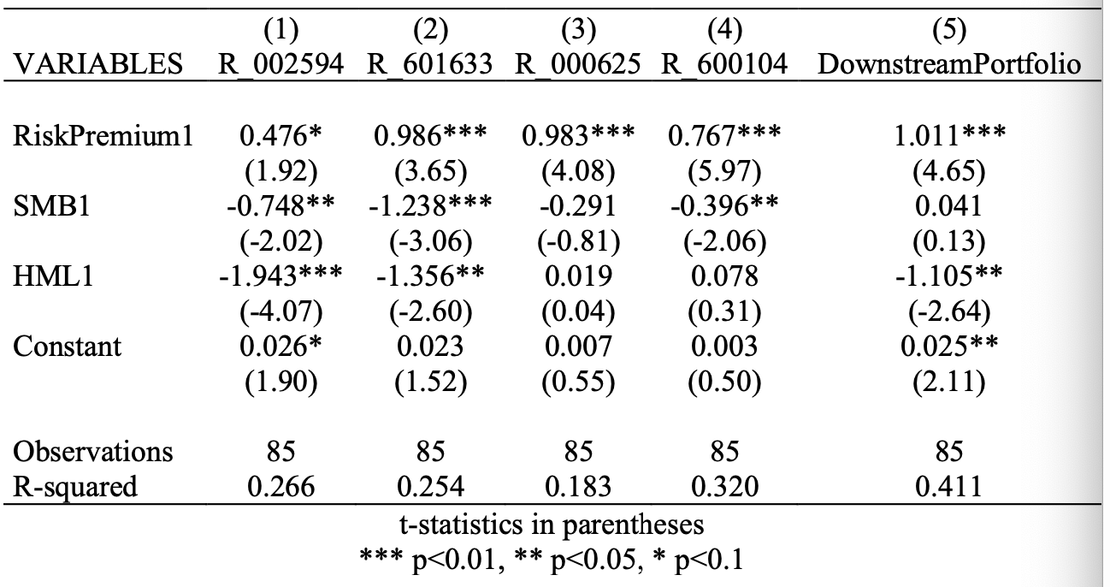

The companies in the above regression results are respectively BYD (002594), Great Wall Motor (601633), Chang'an Motor (000625) and SAIC Motor Group (600104, In the regression results, it can also be seen that BYD is the only company with an unexplained positive, which also shows that BYD has superior returns. As a traditional leader, SAIC Group's excess earnings are best explained, while the insignificant book to market ratio factor may be related to the low valuation of SAIC Group. On the whole, the Fama French three factor model has a good prediction ability for the investment portfolio of vehicle manufacturing enterprises in the downstream of the industrial chain, but there are still some excess returns that cannot be captured.

2.3.4 Summary

Through the Fama French three factor model, we can make a comparative analysis of the upper and middle reaches of the new energy vehicle industry chain. It can be seen that the model is more accurate in predicting the excess return of the investment portfolio of midstream and downstream enterprises, which may be highly related to the profitability of upstream raw material companies, stock prices and raw material prices. The rapid rise and large fluctuations of raw material prices make it difficult to predict the stock prices of upstream raw material companies. The whole industry chain has a certain positive effect, reflecting the high vitality and investment value of the whole new energy vehicle industry. When the new energy concept sector rose, the battery sector, which accounted for a large proportion, rose first. The battery logic is the hardest, the most recognizable, and the cost accounts for the highest proportion. Therefore, when the concept is hyped, the first thing to rise is the battery industry chain, which is logically reasonable, and then gradually transmitted to the electric motor control. From the regression results, the historical data of the electric motor company does not reflect too much unexplained excess earnings, and the excess earnings in the boom stage of the battery company can be used to predict the future, The electric machinery company will go through a prosperous income stage with good investment value. However, with the decline of subsidies for new energy vehicles, new energy vehicle enterprises are bound to usher in a painful period in the future. At this time, upstream and midstream enterprises may be able to gain more attention. The pattern of the new energy industry chain has changed rapidly. For example, AVIC Lithium has doubled its market share in just one year because it entered the supply chain system of Chang'an Automobile and GAC Group in 2019. For example, Founder Electric once went up and down after it entered the supply system of Weilai. Therefore, the analysis of the entire industrial chain cannot be ignored for the investment in the whole new energy vehicles.

To sum up, we have gained a deeper understanding of the industrial chain of new energy vehicles through the Fama French three factor model, and identified the high uncertainty of the profitability of upstream raw material enterprises. Combined with the logic of declining vehicle subsidies and the prosperity of battery enterprises, we believe that motor companies in the middle of the industrial chain and charging piles in the downstream of the industrial chain will have better investment value in the future.

**3. Machine Learning Network Model**

Due to the volatility and nonlinear nature of the financial stock market, it is a very challenging task to accurately predict the stock market returns. Traditional stock forecasting methods and theories mainly include linear regression, random walk theory (RWT), similarities and differences moving average (MACD), autoregressive moving average (ARMA), autoregressive integral moving average (ARIMA), etc. With the introduction of artificial intelligence technology and the improvement of computing power, programmed prediction methods have proved to be more effective in predicting stock prices, and support vector machines (SVM), random forests (RF), artificial neural networks (ANN), convolutional neural networks (CNN), recursive neural networks (RNN), etc. have shown good prediction capabilities.

We use the artificial neural network model to forecast the stock prices of Ningde Times and BYD. First, we introduce the principle of artificial neural network (ANN) for financial time series forecasting.

**3.1 Artificial Neural Network Model**

Artificial Neural Networks (abbreviated as ANN) is an algorithm mathematical model that simulates the behavior characteristics of animal neural networks and conducts distributed parallel information processing. This kind of network relies on the complexity of the system and adjusts the interconnection between a large number of internal nodes to achieve the purpose of processing information, and has the ability of self-learning and adaptive. We use a three-layer artificial neural network, which is composed of input layer, hidden layer and output layer. The specific structure is as follows:

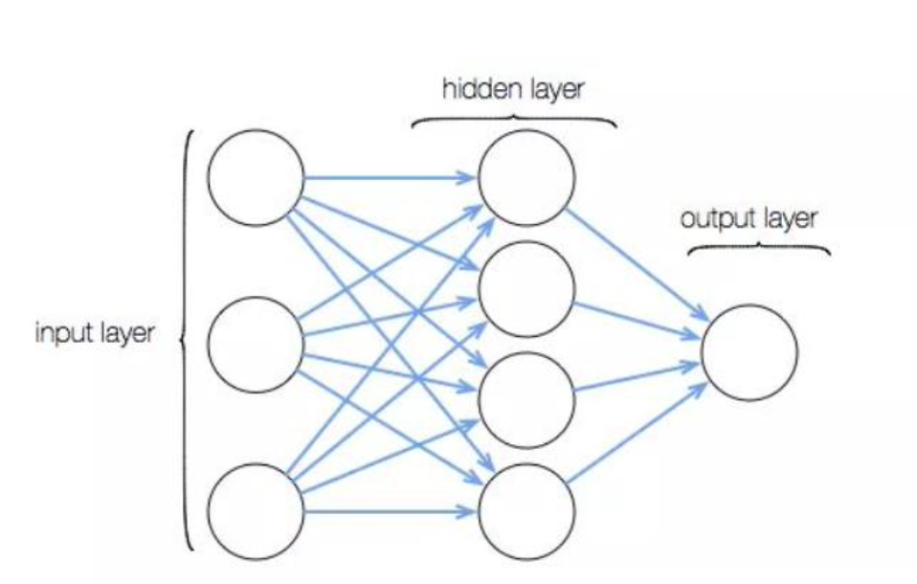

Each layer of the artificial neural network contains several neurons, and each neuron is connected by a directed arc with variable weights. The network processes the relationship between information and analog input and output by repeatedly learning and training the known information and gradually adjusting the method of changing the weights of neuron connections. It does not need to know the exact relationship between input and output, and does not need a large number of parameters. It only needs to know the non constant factors that cause output changes, namely, non constant parameters. Therefore, compared with the traditional data processing methods, the artificial neural network has obvious advantages in processing and predicting the stock price, which is a kind of nonlinear data with strong randomness.

**3.2 Statistical Parameter Model**

To test the effect of this machine learning model on closing price prediction, we use two statistical parameters, namely, root mean square error (RMSE) and average absolute percentage error (MAPE). They are calculated as follows:

represents the original closing price represents the predictive closing price, n represents the total sample size. Higher absolute values represent better predictions.

**3.3 Empirical Analysis**

3.3.1 Data Collection and Variable Calculation

We collected the historical data of the two companies from Jukuan Database, which includes the stock price data of Ningde Times and BYD in daily units from October 10, 2018 to February 10, 2022. In order to use the machine learning model to predict the stock closing price, we have created 6 new variables based on the original data collected:

|  |  |
| --- | --- |
| Variable Names | Explanation |
| H-L | Highest price minus lowest price |
| O-C | Opening price minus closing price |
| 7 DAYS MA | Moving average of closing price in the past 7 days |
| 14 DAYS MA | Moving average of closing price in the past 14 days |
| 21 DAYS MA | Moving average of closing price in the past 21 days |
| 7 DAYS STD DEV | Standard deviation of closing price in the past 7 days |

3.3.2 Model prediction and results

After data collection and calculation of new variables, we began to use the established model for prediction. The training set and test set are divided as follows:

|  |  |
| --- | --- |
| Datasets | Dats |
| All data | 10/10/2018-02/10/2022 |
| Training Set | 10/10/2018-02/10/2021 |
| Test Set | 02/11/2021-02/10/2022 |

After the data set is divided, we use the following neural network to predict: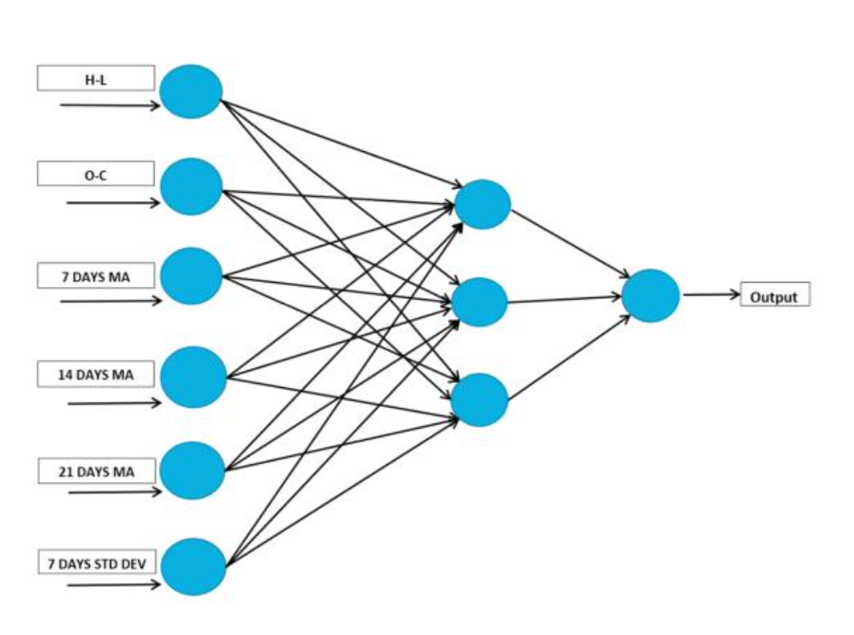

The input is 6 newly created variables: H-L, O-C, 7 DAYS MA, 14 DAYS MA, 21 DAYS MA and 7 DAYS STD DEV, and the output is the closing price of the next day. The prediction results obtained by inputting the test set into the model are as follows:

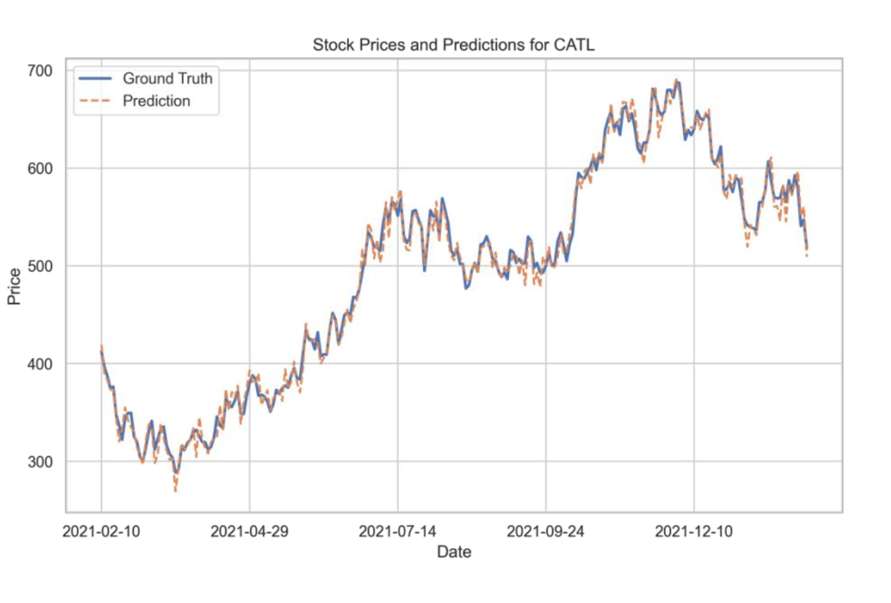

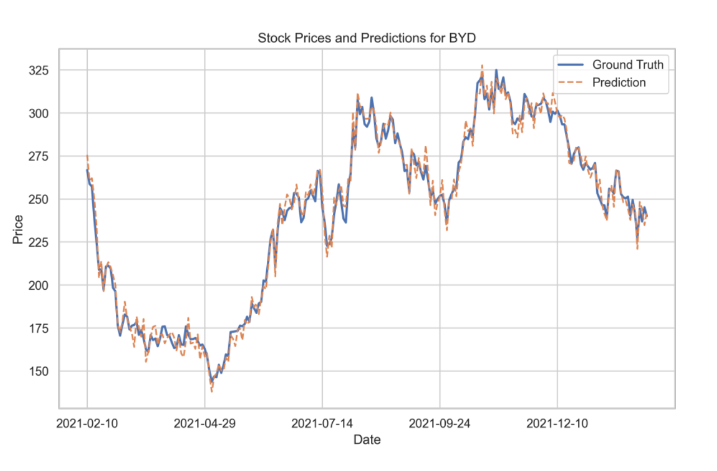

|  |  |  |
| --- | --- | --- |
| Stock\Indicator | RMSE | MAPE |
| BYD | 1.53 | 1.07% |
| Ningde Times | 1.20 | 0.77% |

From the results, ANN has a better prediction effect on both stocks. In contrast, its prediction effect on Ningde Times is better than that of Yadi, which may be related to the continuous rising trend of Ningde Times.

Artificial neural network (ANN) is a relatively basic model in deep learning. We propose a reasonable guess: more complex deep learning models have a broader prospect in the field of stock investment, which is also confirmed by the phenomenon that private placement widely uses deep learning models such as convolutional neural network. It is believed that with the rapid development of machine learning theory, more advanced models will be applied to the field of stock investment and become an important force to change the face of the market.